Azure Data Analytics Case Study

Trip Data Analysis using PySpark on Azure Cloud

1. Introduction
Modern transportation and mobility systems generate large volumes of trip data containing information about travel time, distance, purpose, and location. Analyzing this data can provide valuable insights into travel behavior, operational efficiency, and usage patterns.
Traditional data processing tools struggle to handle large datasets efficiently. Big data technologies enable scalable processing and analysis of such datasets.
This case study focuses on analyzing trip data using Apache Spark with PySpark on cloud infrastructure provided by Microsoft Azure. The analysis aims to identify travel patterns, evaluate efficiency metrics, detect anomalies, and derive insights from the dataset.
The system uses distributed processing to handle large datasets efficiently and uses Python visualization libraries to present analytical insights.

2. Dataset Description
The dataset used for this case study contains trip-level information including time, distance, category, and purpose of travel.
Column | Description
start_date | Date when the trip started
start_hour | Hour when the trip started
start_minute | Minute when the trip started
end_date | Date when the trip ended
end_hour | Hour when the trip ended
end_minute | Minute when the trip ended
month | Month of the trip
year | Year of the trip
CATEGORY | Category of trip (Business or Personal)
START | Starting location of the trip
STOP | Destination location of the trip
MILES | Distance travelled during the trip
PURPOSE | Purpose of the trip
duration | Total duration of the trip
speed | Average speed during the trip
day | Day of the week
day_time | Time segment of the day (morning, afternoon, evening, night)
This dataset allows analysis of travel patterns, efficiency, behavioral insights, and anomaly detection.

3. System Architecture
The big data analytics workflow implemented in Azure follows the architecture below.
- The raw dataset is stored in Azure Data Lake Storage, which provides scalable storage for large datasets.
- Data processing and transformation are performed using Azure Databricks with Apache Spark and PySpark.
- Spark performs distributed processing to clean, transform, and analyze the dataset.
- Aggregated results are generated using Spark SQL and PySpark transformations.
- Analytical insights are visualized using Python libraries such as Matplotlib and Seaborn.
This architecture allows efficient processing of large-scale datasets and supports scalable analytical workflows.

4. Analytical Use Cases

4.1 Trip Duration Analysis
Trip duration analysis helps understand how much time is typically spent on travel.
Objectives
- Calculate average trip duration
- Identify trips with unusually long or short durations
- Compare duration across different trip categories
Benefits
This analysis helps identify inefficient travel patterns and operational delays.

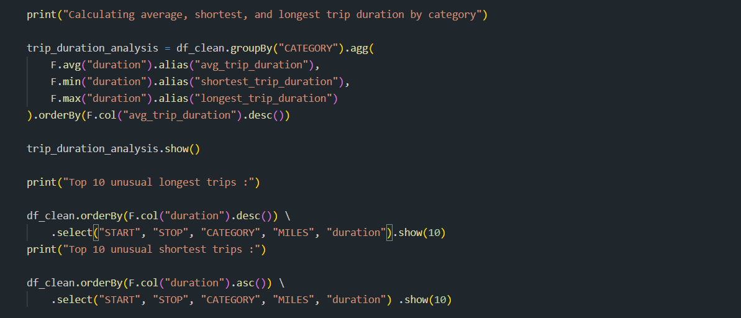

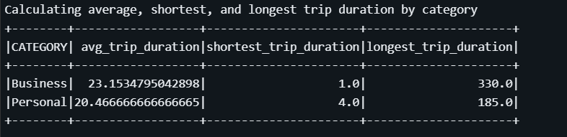
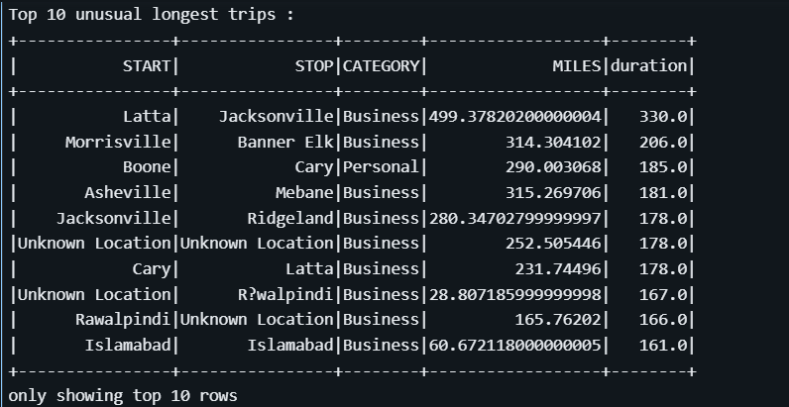
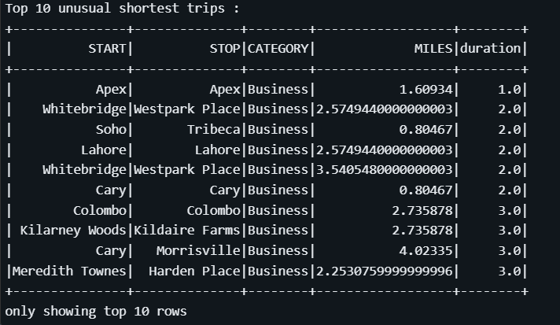

4.2 Distance and Speed Analysis
This analysis studies the relationship between travel distance and average speed.
Objectives
- Calculate average speed for different trip categories
- Identify unrealistic speed values
- Evaluate travel efficiency
Benefits
Detects anomalies and helps understand travel performance.

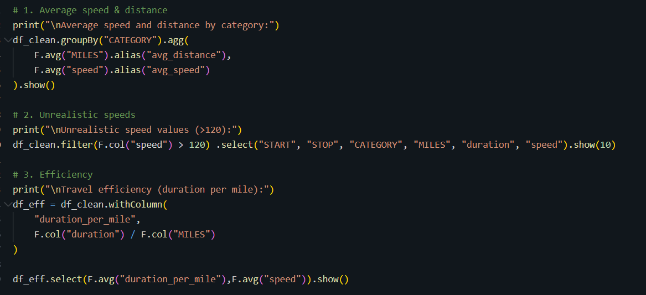
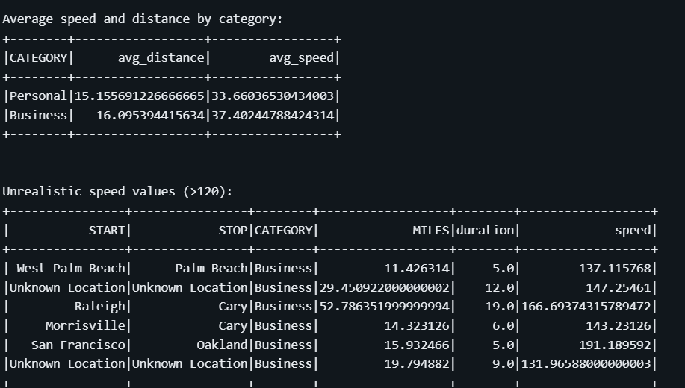
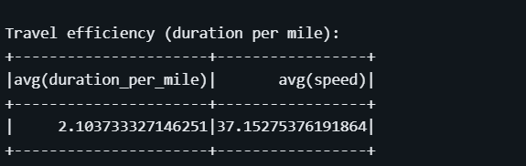

4.3 Time-of-Day Travel Pattern Analysis
Travel activity is analyzed based on the time of day.
Objectives
- Identify peak travel hours
- Analyze trip frequency during different time periods
- Compare travel activity across morning, afternoon, evening, and night
Benefits
Helps understand daily mobility patterns.

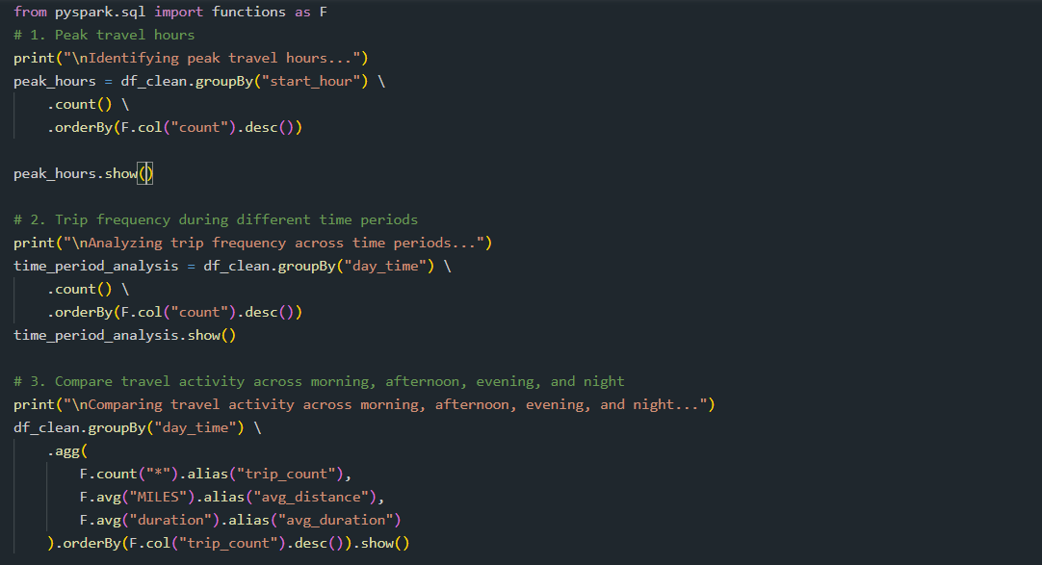
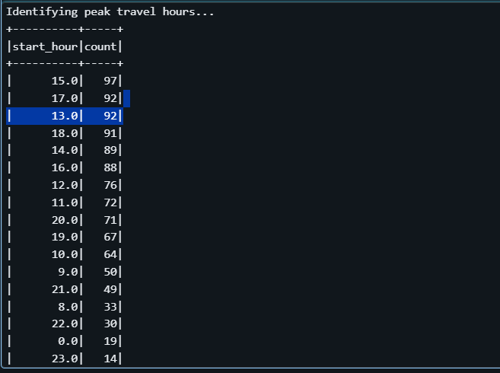
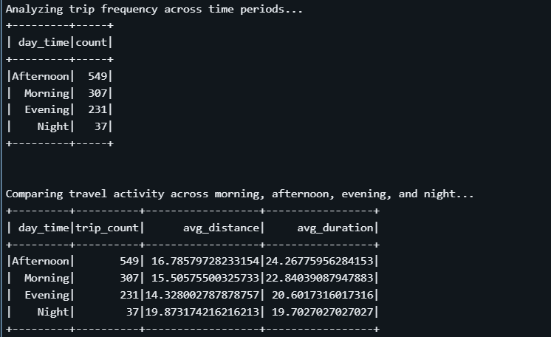

4.4 Day-wise Travel Pattern Analysis
This analysis examines travel patterns across different days of the week.
Objectives
- Identify the busiest days for travel
- Compare weekday and weekend travel behavior
- Measure total distance travelled per day
Benefits
Supports planning and resource allocation.

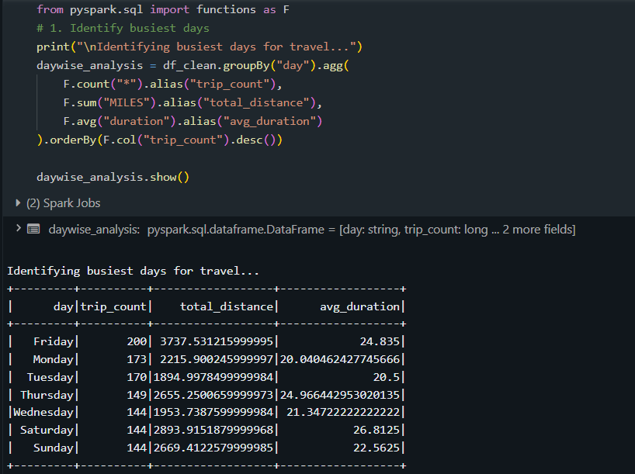
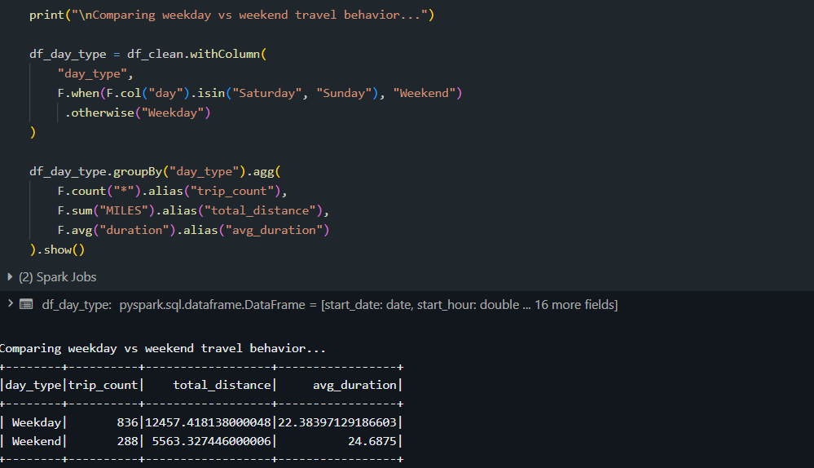

4.5 Category-Based Trip Analysis
Trips are analyzed based on category to identify behavioral differences.
Objectives
- Compare business and personal travel
- Analyze average distance and duration for each category
- Identify dominant travel purposes
Benefits
Provides insights into travel behavior.
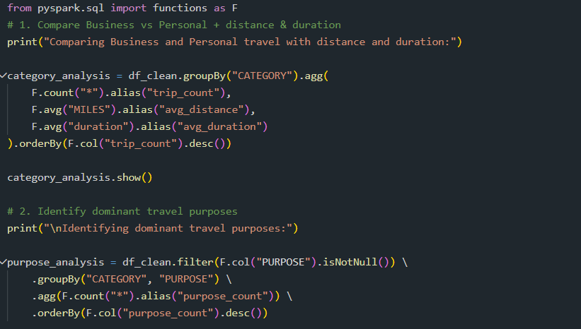

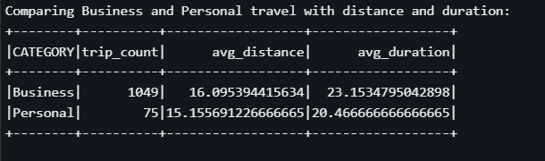
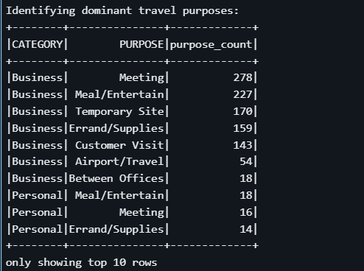

4.6 Monthly Travel Trend Analysis
Travel data is analyzed across months to identify seasonal patterns.
Objectives
- Calculate total trips per month
- Identify months with highest travel activity
- Analyze trends across years
Benefits
Helps identify seasonal demand.
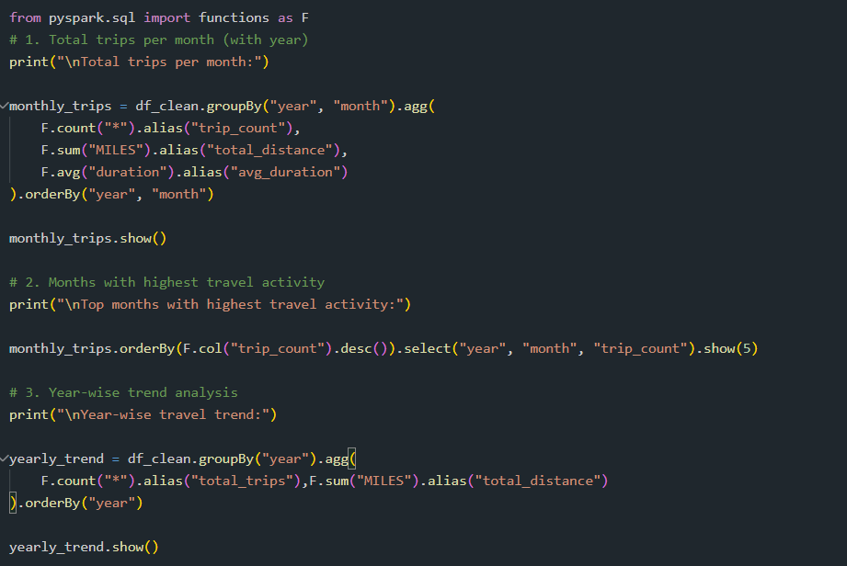
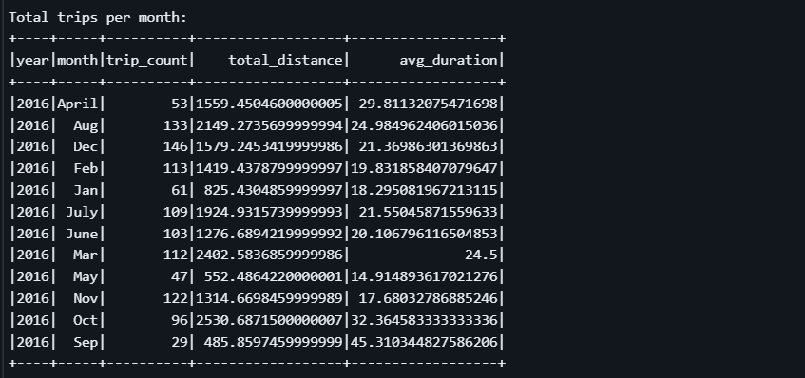
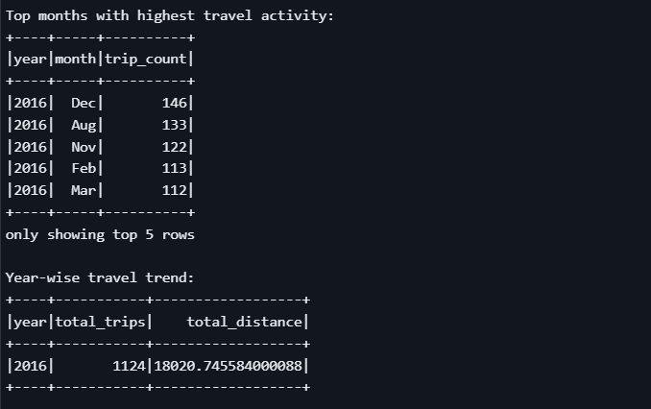

4.7 Travel Efficiency Analysis
Efficiency analysis measures how effectively travel resources are utilized.
Metrics
- Miles travelled per trip
- Duration per mile
- Average speed
Benefits
Helps identify inefficient travel patterns and potential improvements.
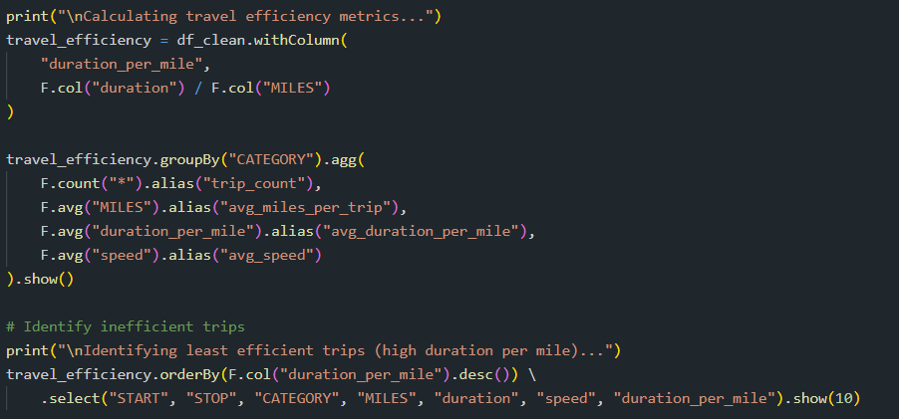
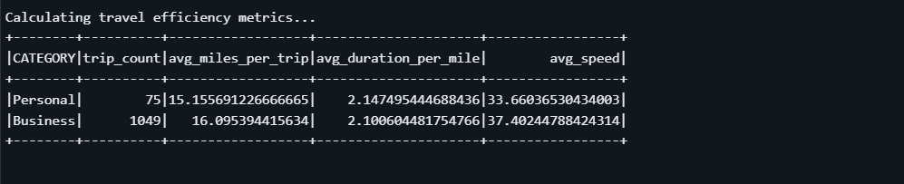
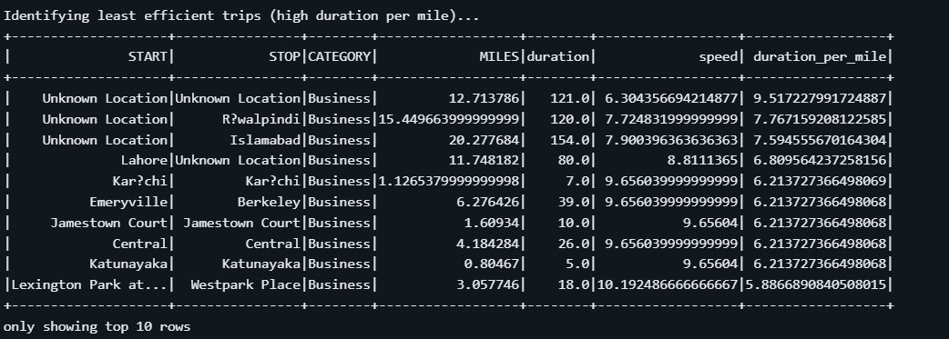

4.8 Peak Travel Period Detection
This analysis identifies periods with the highest travel demand.
Objectives
- Count trips per hour
- Identify peak travel windows
- Analyze travel distribution across time segments
Benefits
Supports demand forecasting and traffic analysis.
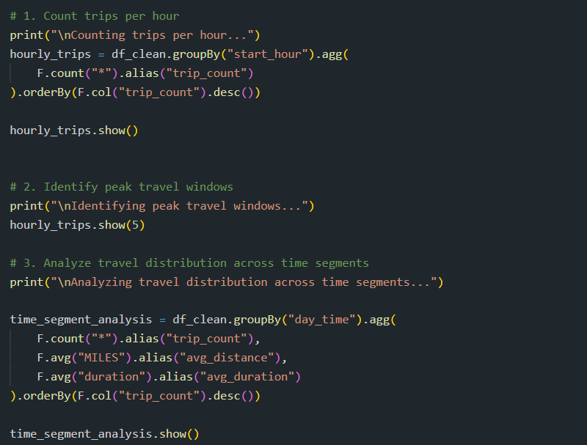
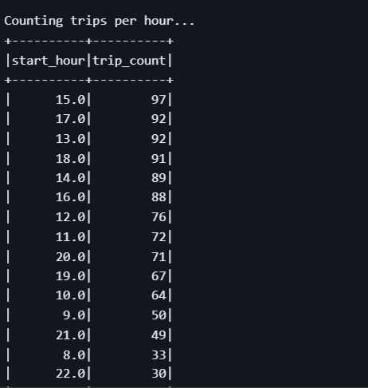
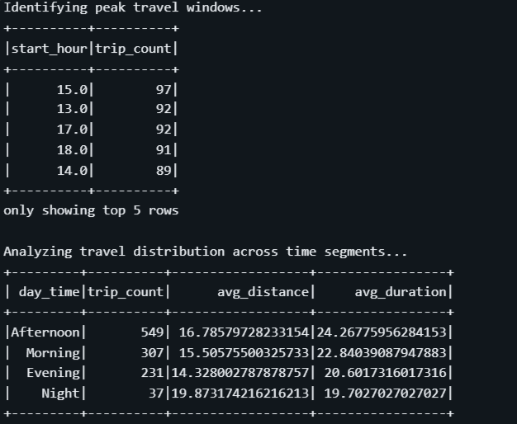

4.9 Long Distance Trip Identification
This analysis identifies trips that involve significant distance or time.
Objectives
- Detect trips exceeding predefined distance thresholds
- Identify trips with unusually long duration
- Analyze high-resource travel patterns
Benefits
Helps evaluate travel costs and logistics.
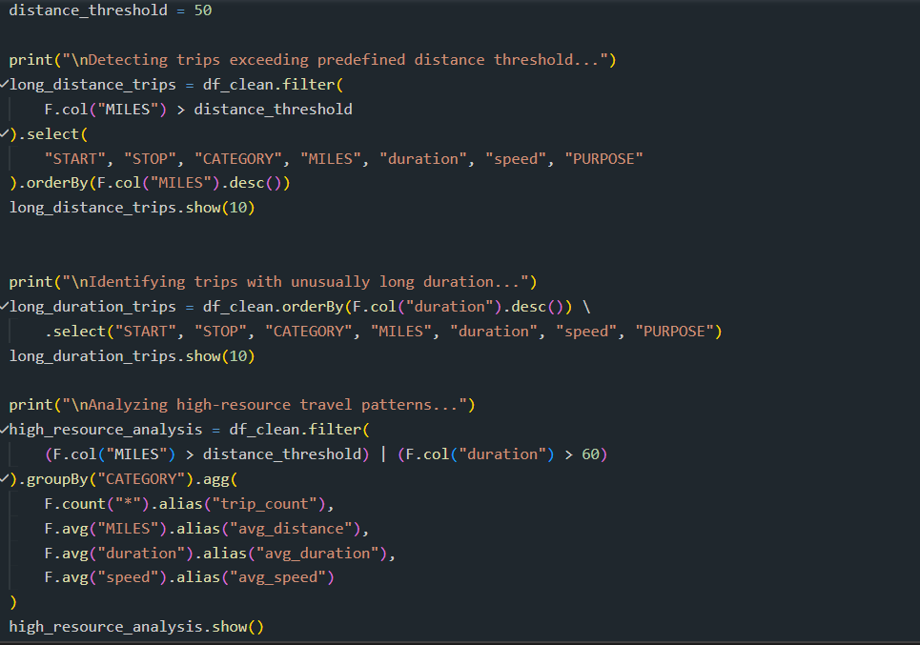
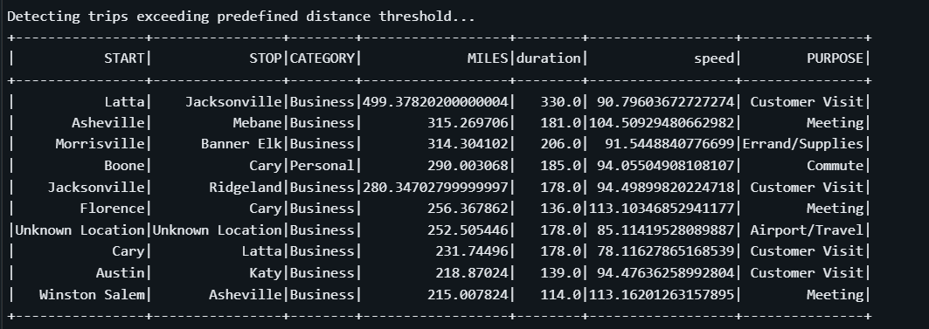
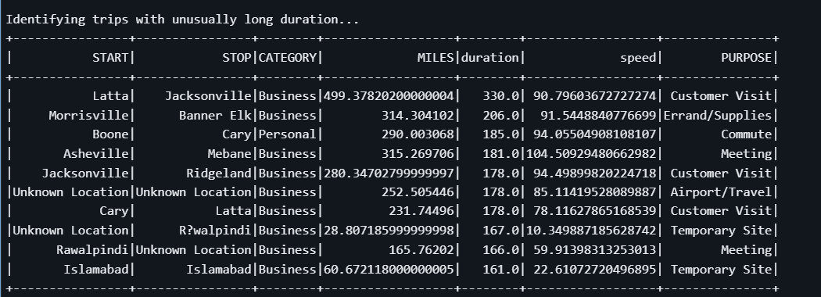
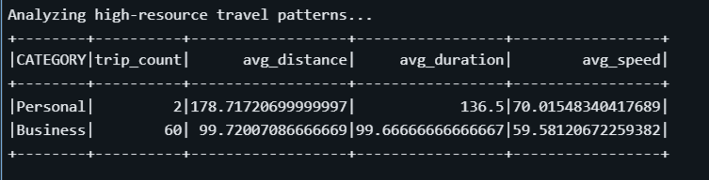

4.10 Data Quality Monitoring
This analysis ensures the dataset is clean and reliable.
Possible Data Issues
- Negative trip duration
- Missing values
- Unrealistic speeds
- Trips with zero distance but long duration
- End time earlier than start time
Benefits
Improves reliability of analytical results.

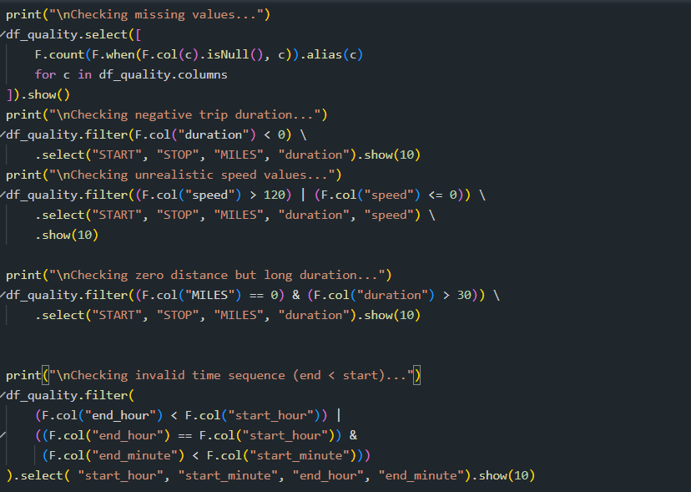
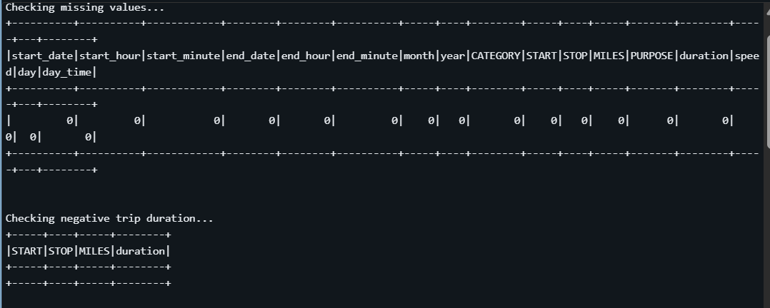
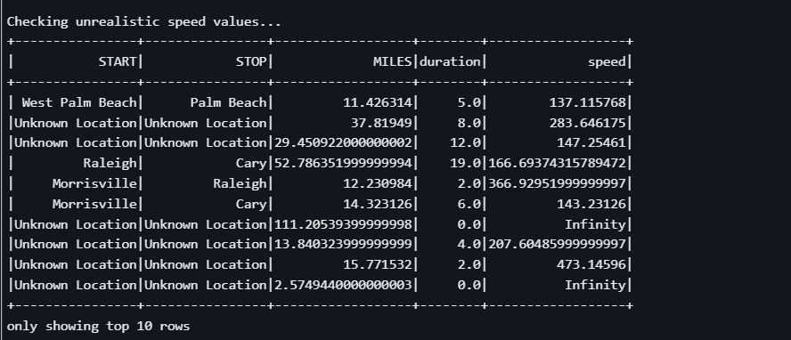
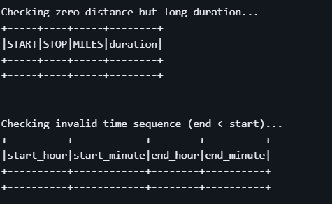

4.11 Travel Behavior Segmentation
Machine learning methods can be applied to identify clusters of similar trips.
Features Used
- Distance
- Duration
- Speed
- Time of day
Clustering algorithms can group trips with similar patterns.
Benefits
Helps identify distinct travel behaviors.
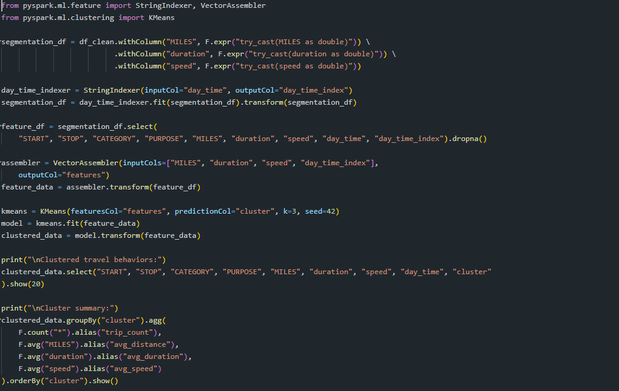
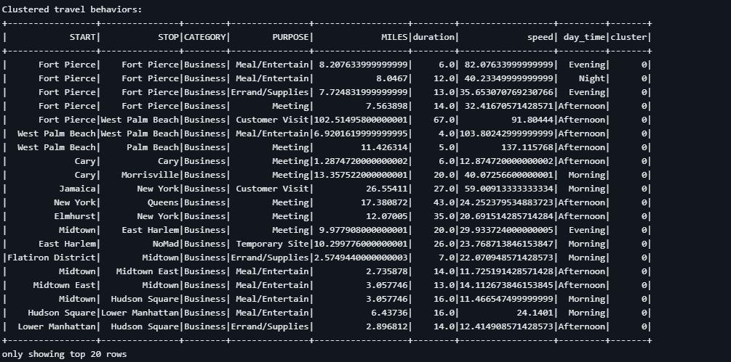
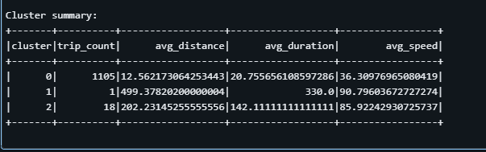

4.12 Travel Duration Prediction
Predictive models can estimate travel time based on historical data.
Features
- Distance travelled
- Time of day
- Day of the week
- Trip category
Regression models can be trained using Spark machine learning libraries.
Benefits
Improves planning and travel time estimation.

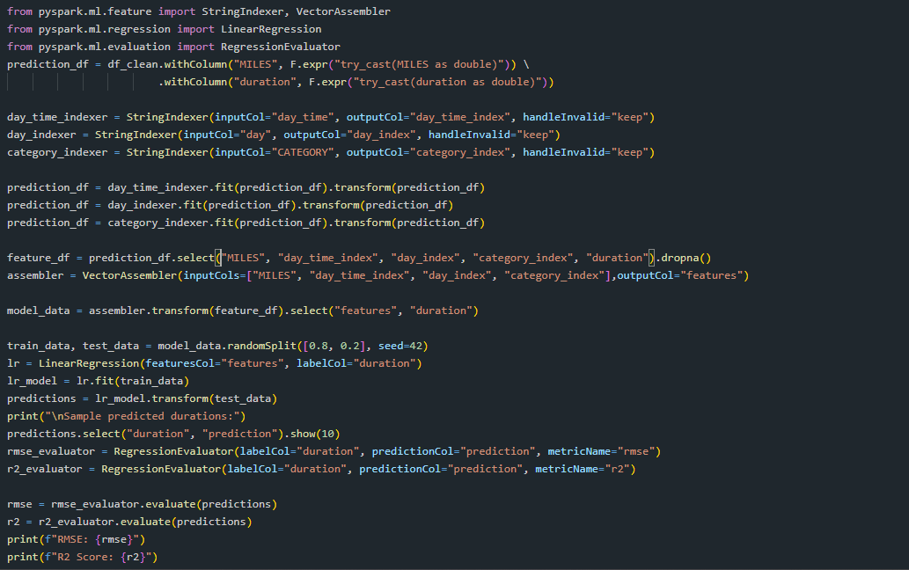
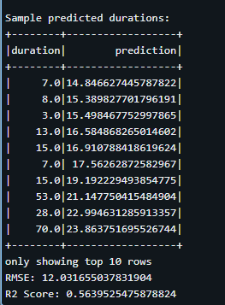

5. Tools and Technologies
The following technologies are used in this big data analytics workflow:
- Microsoft Azure
- Azure Data Lake Storage
- Azure Databricks
- Apache Spark
- PySpark
- Python
- Matplotlib
- Seaborn
These tools enable scalable storage, distributed processing, and effective data visualization.

6. Visualization and Reporting
After processing the dataset using PySpark, the analytical results are visualized using Python libraries such as Matplotlib and Seaborn.
Since PySpark processes large volumes of data, aggregated results are first computed using Spark transformations. These results are then converted into Pandas DataFrames for visualization.

Key Visualizations
Trip Frequency by Hour
Displays the number of trips occurring during each hour of the day.
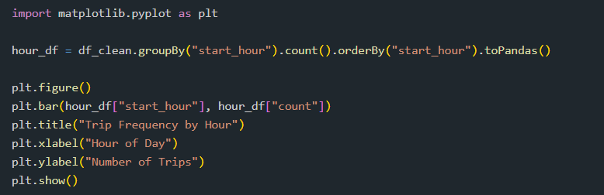
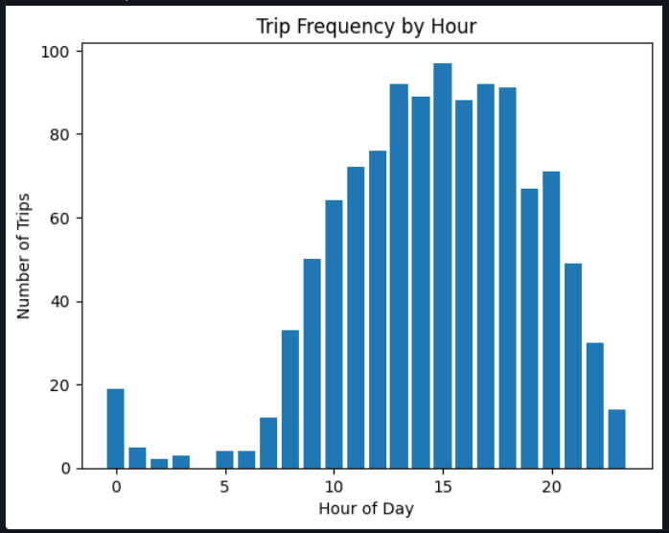
Distance Distribution
Shows how trip distances are distributed across the dataset.

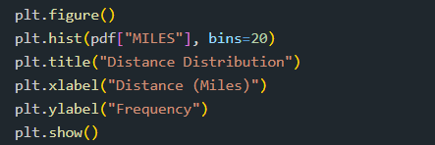

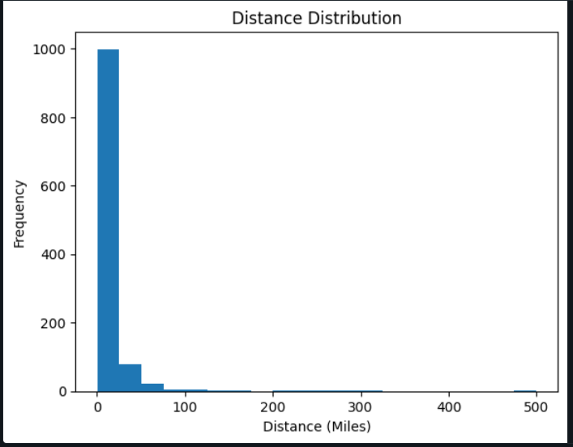
Distance vs Duration Relationship
A scatter plot that illustrates how trip duration changes with travel distance.

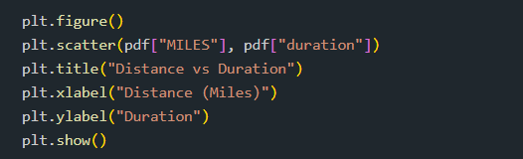
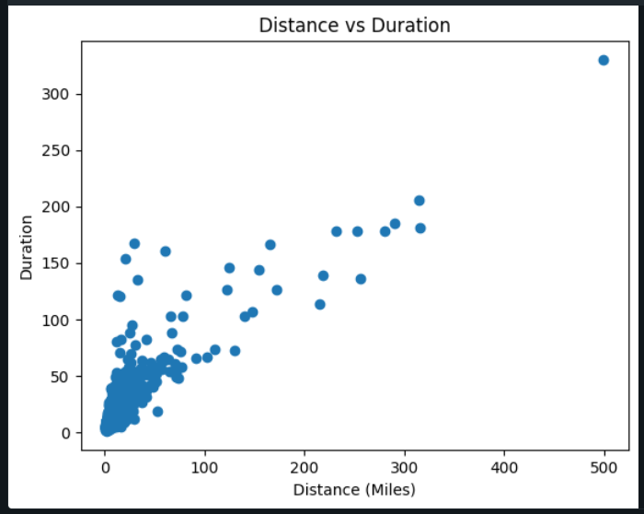
Trips by Category
Compares trip counts between business and personal travel.
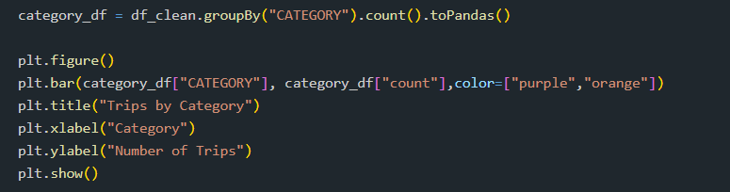
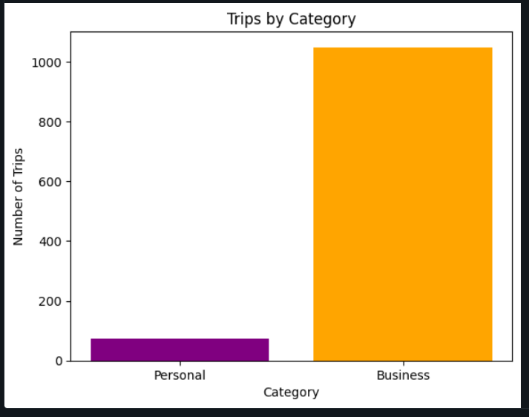
Trips by Day of the Week
Shows travel patterns across different days.
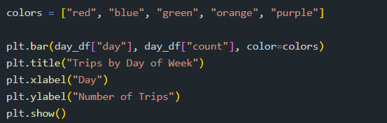
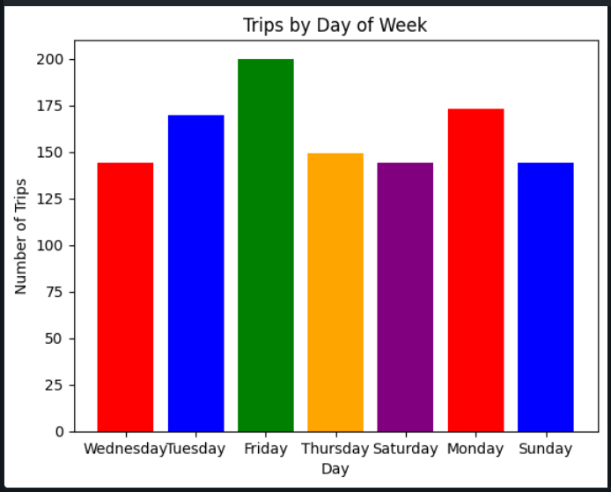
These visualizations help convert analytical outputs into easily interpretable insights.

7. Expected Outcomes
The implementation of this analytical framework produces several valuable outcomes:
- Identification of peak travel hours
- Understanding of travel behavior patterns
- Detection of data anomalies
- Evaluation of travel efficiency
- Insights into trip categories and purposes
- Predictive capability for estimating travel duration
These insights support data-driven decision making.

8. Conclusion
Big data analytics using PySpark on Azure provides a scalable platform for processing and analyzing large datasets. By applying distributed data processing techniques, the system can efficiently analyze travel patterns, identify inefficiencies, and detect anomalies.
The integration of Azure cloud infrastructure with Spark processing and Python visualization tools enables efficient data analysis and reporting. This approach allows organizations to transform raw trip data into actionable insights that support operational improvements and strategic planning.

